**AWS ASSIGNMENT**

1. Navigate to the IAM service within the AWS Management Console

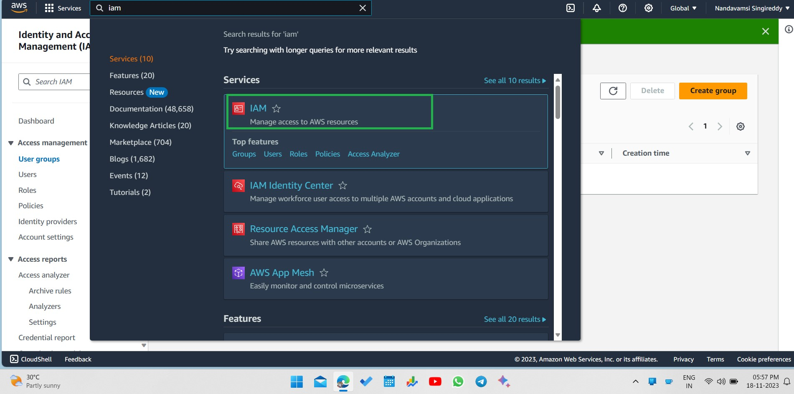

1. Establish user groups for developers, QA testers, and administrators within the IAM console.

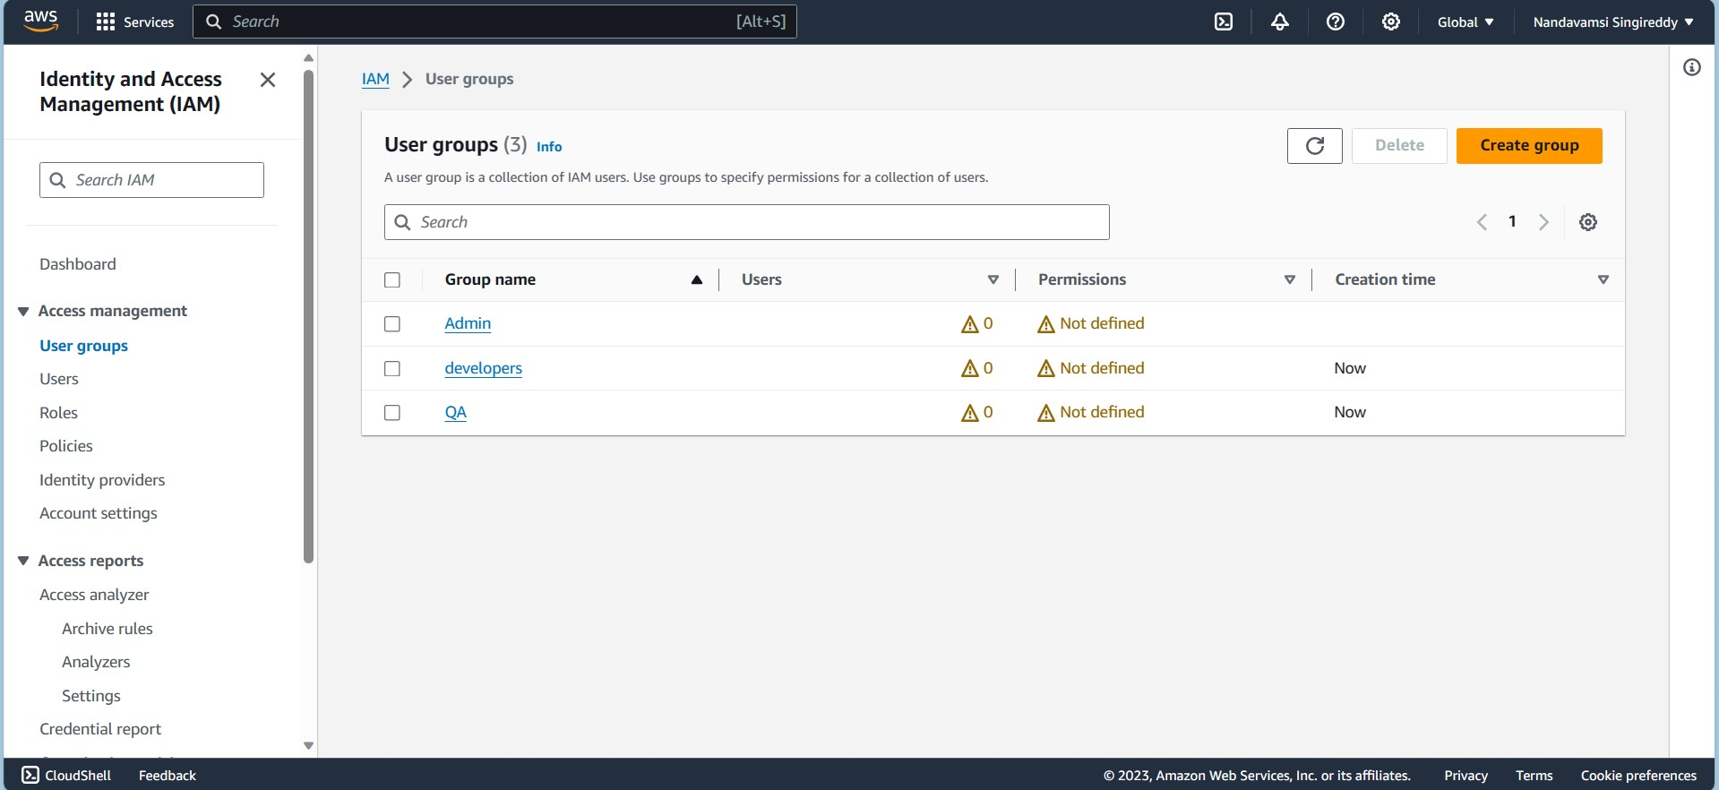

1. Enroll individuals as members of the respective user groups.

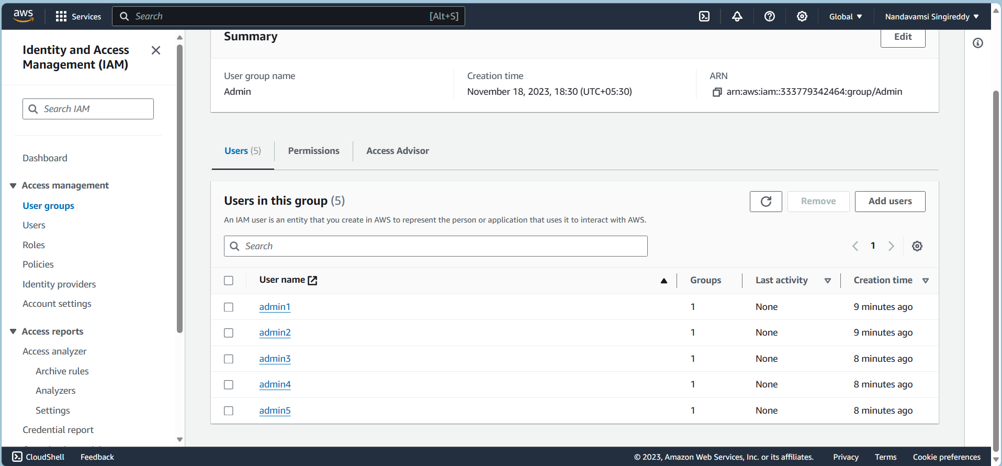

1. Grant the Developer User Group permissions to create, manage, but not terminate EC2 instances, establish and manage VPC networks without the ability to delete them, and create but not delete S3 buckets.

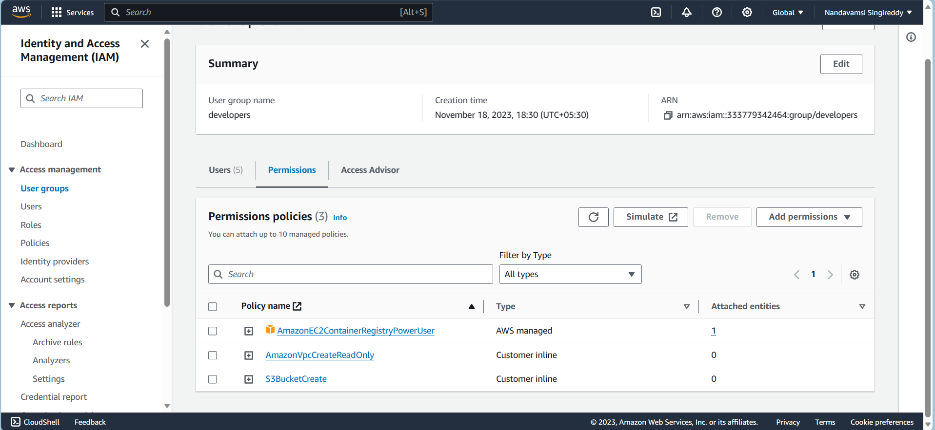

1. Grand QA user group permissions to read only for easy to instance and VPC and S3 bucket

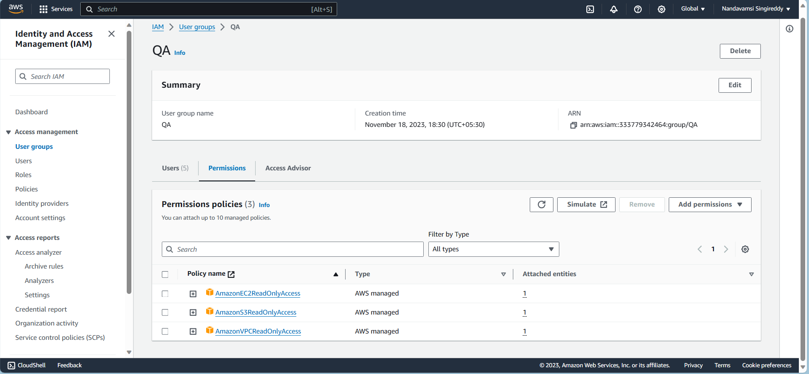

1. Grand admin user group full access for EC2 instance,S3 bucket and VPC

